**Jedlownik**

**Jedlownik i**s the oldest parish of the Archdiocese of Katowice. In 1239 the owner of the village was Goslaw, who, before the invasion of the Tatars, possessed extensive goods near Raciborz. It is likely that in his headquarters – Jedlownik, he founded a church already in the early 13th century. In the sixteenth century. The former parish church, wooden, rebuilt in the first half of the seventeenth century was originally St. Mark church. In 1688 beside St. Mark, St. Barbara appeared as a patron. In the eighteenth century, St. Mark as patron went into oblivion and St. Barbara remained as the only patron Saint. The church was renovated in 1885. In 1974 it was moved to Jastrzebie Zdroj, where it was consecrated December 3rd 1974.

The present church of Our Lady of Graces and św.Antoniego Wszechpośredniczki of Padua was built between 1949-1952. Dedicated on September 21, 1952 by Bishop Coadjutor Herbert Bednorz. The designer of the church was Hanak of Olše. The interior was designed by artist Joseph Kołodziejczyk. The parish is located Nursing Home run by the Sisters of Divine Providence - General House in Grodzisk. Assembly it took possession of the castle and the adjacent garden. Between the Sisters led facility for morally neglected girls. During the war years 1940-1945 the house was earmarked as a shelter for displaced people. After the war, in 1945, the Sisters regained home organizing in the facility caring for orphans, then for severely retarded girls.

Jedlownik from air ☺

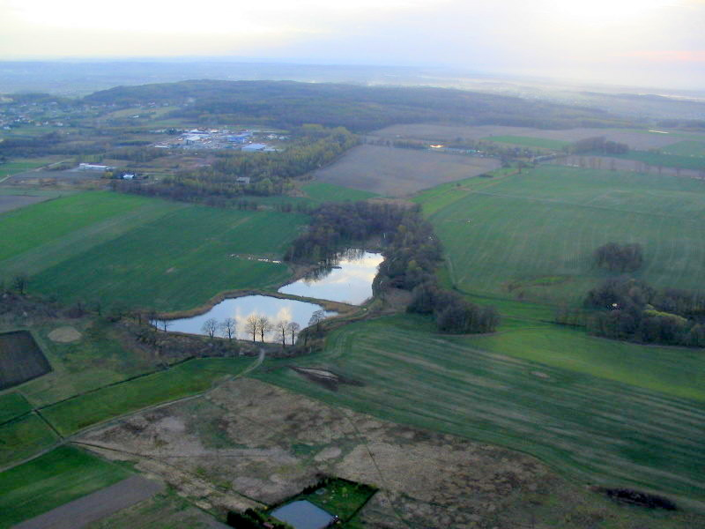

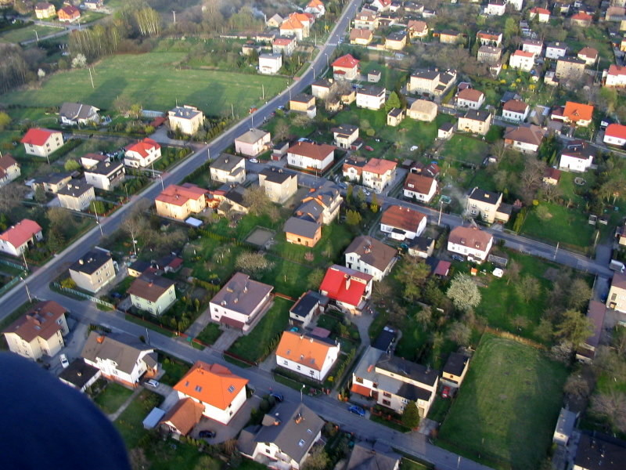

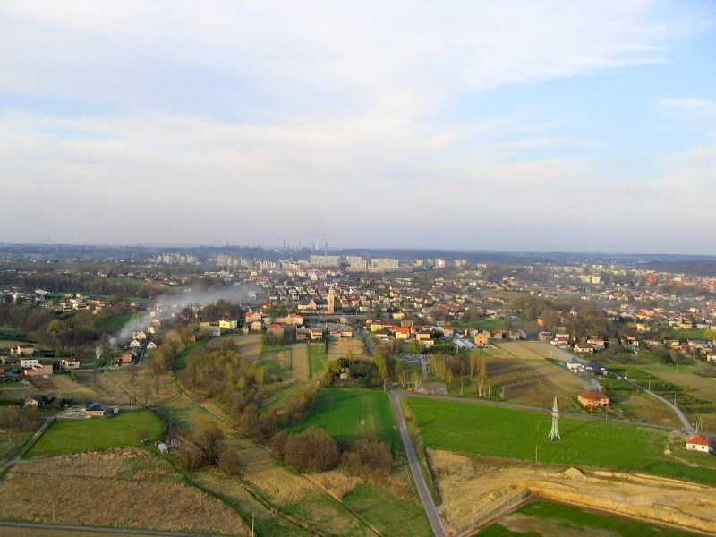

**THE CHURCH**

